Messaging & Communication APIs

💬 What Are Messaging & Communication APIs?
# Source: AI Source: Provided by: [Data Path: Persons Table -> ID Column: 1, Name_En Column: Motasem Essam] -> From: [ChatGPT] on [1/19/2026]
Messaging & Communication APIs are web service interfaces that allow developers to send, receive, and manage communication between applications and users — including SMS, emails, voice calls, chat messages, and push notifications.
They are widely used in apps for user notifications, OTPs, support chats, and alerts.

✅ What Messaging & Communication APIs Can Do
# Source: AI Source: Provided by: [Data Path: Persons Table -> ID Column: 1, Name_En Column: Motasem Essam] -> From: [ChatGPT] on [1/19/2026]
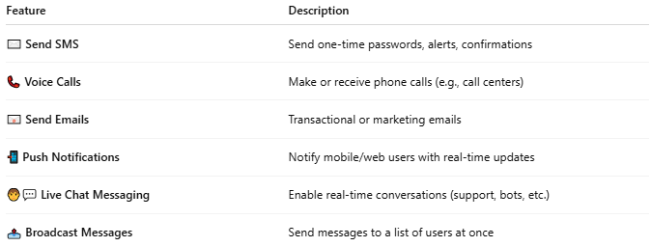

Feature | Description
✉️ Send SMS | Send one-time passwords, alerts, confirmations
📞 Voice Calls | Make or receive phone calls (e.g., call centers)
📧 Send Emails | Transactional or marketing emails
📲 Push Notifications | Notify mobile/web users with real-time updates
🧑‍💬 Live Chat Messaging | Enable real-time conversations (support, bots, etc.)
📤 Broadcast Messages | Send messages to a list of users at once

🧩 Popular Messaging & Communication APIs
# Source: AI Source: Provided by: [Data Path: Persons Table -> ID Column: 1, Name_En Column: Motasem Essam] -> From: [ChatGPT] on [1/19/2026]
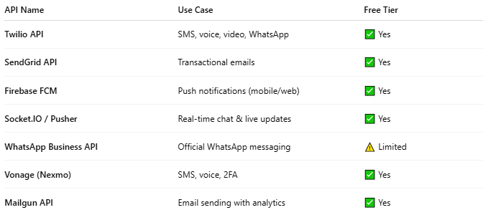

API Name | Use Case | Free Tier
Twilio API | SMS, voice, video, WhatsApp | ✅ Yes
SendGrid API | Transactional emails | ✅ Yes
Firebase FCM | Push notifications (mobile/web) | ✅ Yes
Socket.IO / Pusher | Real-time chat & live updates | ✅ Yes
WhatsApp Business API | Official WhatsApp messaging | ⚠️ Limited
Vonage (Nexmo) | SMS, voice, 2FA | ✅ Yes
Mailgun API | Email sending with analytics | ✅ Yes

📤 Example: Send SMS via Twilio API (PHP)
# Source: AI Source: Provided by: [Data Path: Persons Table -> ID Column: 1, Name_En Column: Motasem Essam] -> From: [ChatGPT] on [1/19/2026]
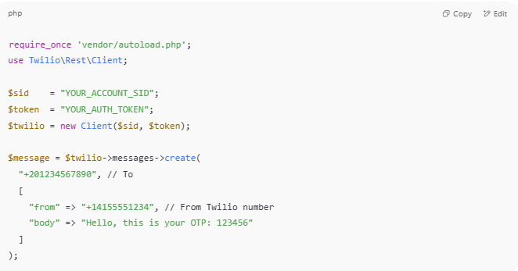

require_once 'vendor/autoload.php';
use Twilio\Rest\Client;

$sid = "YOUR_ACCOUNT_SID";
$token = "YOUR_AUTH_TOKEN";
$twilio = new Client($sid, $token);

$message = $twilio->messages->create(
"+201234567890", // To
[
"from" => "+14155551234", // From Twilio number
"body" => "Hello, this is your OTP: 123456"
]
);

📧 Example: Send Email via SendGrid API
# Source: AI Source: Provided by: [Data Path: Persons Table -> ID Column: 1, Name_En Column: Motasem Essam] -> From: [ChatGPT] on [1/19/2026]
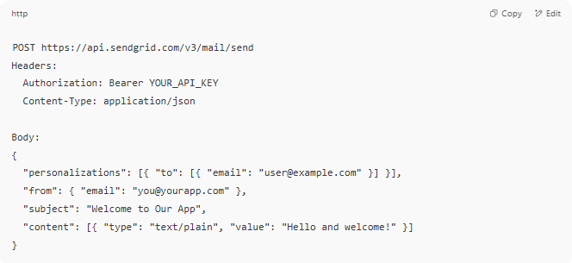

POST https://api.sendgrid.com/v3/mail/send
Headers:
Authorization: Bearer YOUR_API_KEY
Content-Type: application/json

Body:
{
"personalizations": [{ "to": [{ "email": "user@example.com" }] }],
"from": { "email": "you@yourapp.com" },
"subject": "Welcome to Our App",
"content": [{ "type": "text/plain", "value": "Hello and welcome!" }]
}

🔐 Security Features
# Source: AI Source: Provided by: [Data Path: Persons Table -> ID Column: 1, Name_En Column: Motasem Essam] -> From: [ChatGPT] on [1/19/2026]
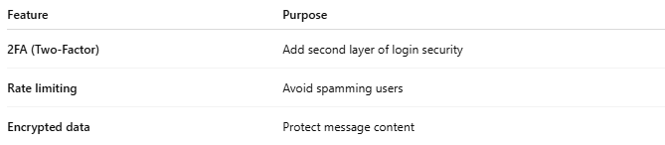

Feature | Purpose
2FA (Two-Factor) | Add second layer of login security
Rate limiting | Avoid spamming users
Encrypted data | Protect message content

🧪 Use Cases
# Source: AI Source: Provided by: [Data Path: Persons Table -> ID Column: 1, Name_En Column: Motasem Essam] -> From: [ChatGPT] on [1/19/2026]
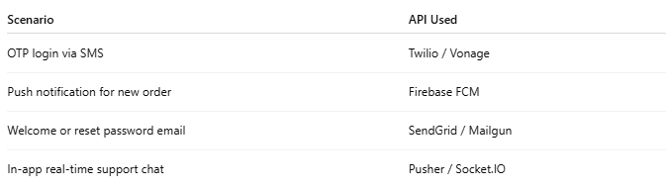

Scenario | API Used
OTP login via SMS | Twilio / Vonage
Push notification for new order | Firebase FCM
Welcome or reset password email | SendGrid / Mailgun
In-app real-time support chat | Pusher / Socket.IO

